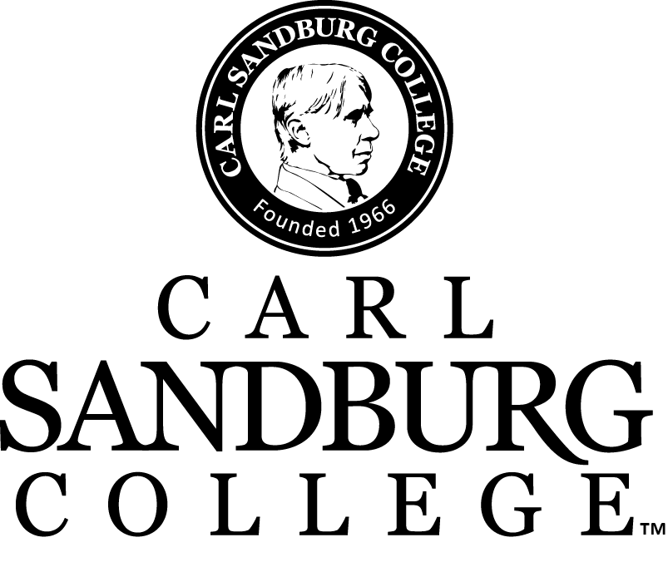

Credit Granting Guide

Faculty Assembly approval: 2/21/2020, 11/19/2021, 10/21/2022, 10/20/2023
Last updated 10/23/2023

CREDIT TYPES
Students enrolled at Carl Sandburg College may receive credit for prior experience in the following categories:
- Advanced Placement Program (AP)
- Bi-Literacy Seal
- Credits earned at accredited colleges or universities from those institutions listed in the American Council on Education’s Accredited Institutions of Postsecondary Education
- College Level Examination Program (CLEP)
- Defense Activity for Non-Traditional Education Support (DANTES)/ United States Armed Forces Institute (USAF)
- International Baccalaureate Exam (IB)
- Military Service & Military Service Schools
- Miscellaneous Credit Approved by Carl Sandburg College Faculty Assembly
Students must earn a minimum of 15 hours of the required total for degrees, and one third of the required hours for certificates through completion of classes at the Carl Sandburg College to be awarded the degree or certificate.
All credit hours awarded are in semester hours.
Approval for the various credits described in this guide have been made by the Carl Sandburg College Faculty Assembly.
The student must formally request evaluation of credit by submitting this completed form to:
Carl Sandburg College
Admissions & Records Office, E100
2400 Tom L. Wilson Blvd.
Galesburg, IL 61401

ADVANCED PLACEMENT PROGRAM (AP)
Carl Sandburg College will award credit for Advanced Placement (AP) exams based upon recommended scores determined by appropriate Sandburg academic departments. Any score of three (3) or better will be accepted as credit; however, the listed score will be required to meet the course equivalent. Credit will be awarded as follows:
Subject | Required Score | Sandburg Course
Art History | 3 | ART 112 & ART 113
Art/Studio (Drawing or General Portfolio) Art & Design Program  AP 2D Art & Design exam  AP 3D Art & Design exam  AP Drawing exam | 3 | ART.121, ART.122 or Art.131  *Max hours awarded is 6 credits. “Faculty recommendation”
Biology | 3 | BIO 101 4
Calculus AB | 3 | MAT 240
Calculus BC | 3 | MAT 240 & MAT 241
Chemistry | 3  4 | CHM 110  CHM 110 & CHM 120
Chinese Language & Culture | 4 | Elective Credit 8
Computer Science A | 3 | ICT.131
Computer Science Principles | 3 | ICT.120
English Language & Comp | 3 | ENG 101 & ENG 102
English Literature & Comp | 3 | ENG 231 & ENG 232
Environmental Science | 3 | BIO 120
European History | 3 | Elective credit - 6
French Language | 3 | FRE 101 & 102
German Language | 3  4 | GER 101  GER 101 & 102
Comparative Government & Politics | 3 | POS 267
U.S. Government & Politics | 3 | POS 122
Human Geography | 3 | GEO 100
Italian Language & Culture | 3  4 | Elective credit - 4  Elective credit - 8
Japanese Language & Culture | 3  4 | Elective credit - 4  Elective credit - 8
Latin Literature | 3  4 | Elective credit - 4  Elective credit- 8
Macroeconomics | 3 | ECO 201
Microeconomics | 3 | ECO 202
Music Theory | 3 | Elective credit - 3
Physics 1: Algebra | 3 | PHY 151
Physics 2: Algebra | 3 | PHY 152
Physics C: Electricity & Magnetism | 3 | PHY 161
Physics C: Mechanics | 3 | PHY 162
Psychology | 3 | PSY 101
Spanish Language & Culture | 3  4  5 | SPN 101  SPN 101 & SPN 102  SPN 201 & 202
Spanish Literature & Culture | 3 | Elective 8
Statistics | 3 | MAT 210
U.S. History | 3 | HIS 105 & HIS 106
World History -Modern | 3 | HIS 125 & HIS 126

BILITERACY SEAL OF APPROVAL
The Illinois State Seal of Biliteracy posted to a student’s high school transcript will be evaluated as twelve (12) credit hours of foreign language coursework at Carl Sandburg College (levels 151, 152, and 251). Credit granted will be based on foreign language course equivalencies, or elective credit.

Credit must be applied to the college transcript within three academic years of high school graduation.

CARL SANDBURG COLLEGE PROFICIENCY EXAMINATIONS
In accordance with state and federal legislation, as well as, accreditation guidelines,
Carl Sandburg College offers optional proficiency assessments to determine if a student has already obtained the knowledge and the skills taught in a particular course. Assessments are provided and evaluated prior to the student taking the course. Credit may also be given for previous training, awarded professional certificates, and/or awarded state or federal licenses and certificates. Awarding of credit is at the discretion of the department.
CREDITS FROM ACCREDITED COLLEGES OR UNIVERSITIES
Students who have attended other colleges or universities may transfer credit to Carl Sandburg College according to the following conditions and on submission of official transcripts:
- The college or university previously attended must be accredited by an American Council on Education (ACE) approved accreditation association.
- The agency and or organization has an approved credit granting agreement with
Carl Sandburg College.
- Credit will be granted for courses in which a grade of C or better has been earned.
- Credit will also be awarded for courses in which a grade of D has been earned providing the student’s overall grade point average is a 2.0 or better unless otherwise stated by specific Carl Sandburg College program requirements.
- Only credit hours are transferable. Grades associated with the credit are not transferable nor are they included in computing the student’s cumulative grade point average at Carl Sandburg College.
- Transfer credit will only be accepted for courses applicable to the student’s Carl Sandburg College program. Only courses applicable to the student’s Carl Sandburg College academic program are accepted in transfer. Should the student’s program change, the student may request a re-evaluation of previously earned credits.

COLLEGE LEVEL EXAMINATION PROGRAM (CLEP)
The College recognizes undergraduate achievement as measured by both the general and subject examinations of the College Level Examination Program (CLEP). Scores may be submitted to the Admissions and Records Office for evaluation, and if the level of achievement is at or above the minimum standards and score levels established by the College, credit may be granted. Carl Sandburg College follows the guidelines of the American Council on Education in accepting CLEP credit. Students may earn up to 24 hours of credit from the general examinations of the College Level Examination Program in the areas of humanities, mathematics, natural sciences and social sciences. In addition, many of the CLEP subject examinations may be accepted for credit based upon the score recommendations of the American Council on Education.
Students should discuss the CLEP options with the Registrar’s office prior to registering for any of the examinations. Regardless of the number of hours earned through CLEP, the student must meet the College's residency requirement for graduation.

 | Computer Based Testing (CBT) and Paper and Pencil Testing
 | ACE Recommended Score | CSC Course & Semester Hours
Business
Financial Accounting | 50 | ACC 101 3
Information Systems | 50 | ICT 120 3
Introductory Business Law | 50 | BLA 201 3
Principles of Management | 50 | BUS 205 3
Principles of Marketing | 50 | BUS 101 3
Composition and Literature
American Literature | 50 | ENG 221 3
Analyzing & Interpreting Literature | 50 | AA/AS ELECTIVE 3
College Composition | 50 | ENG 101 & 102 6
College Composition Modular | 50 | ENG 101 3
English Literature | 50 | ENG 231 3
Humanities | 50 | AA/AS Humanities Gen Ed 3
World Languages
French Language, Level 1 | 50 | FRE 101 & 102 8
French Language, Level 2 | 59 | N/A
German Language, Level 1 | 50  60 | GER 101 4  GER 101 &102 8
German Language, Level 2 | 60 | N/A
Spanish Language, Level 1 | 50 | SPN 101 & 102 8
Spanish Language, Level 2 | 63 | SPN 201 & 202 6

History and Social Sciences
American Government | 50 | POS 122 3
History of the United States I: | 50 | HIS 105 3
History of the United States II: | 50 | HIS 106 3
Human Growth and Development | 50 | PSY 265 3
Introduction to Educational Psychology | 50 | EDU 201 3
Introductory Psychology | 50 | PSY 101 3
Introductory Sociology | 50 | SOC 101 3
Principles of Macroeconomics | 50 | ECO 201 3
Principles of Microeconomics | 50 | ECO 202 3
Social Sciences and History | 50 | AA/AS ELECTIVE 6
Western Civilization I: Ancient Near East to 1648 | 50 | HIS 125 3
Western Civilization II: 1648 to Present | 50 | HIS 126 3
Science and Mathematics
Biology | 50 | BIO 101 4
Calculus | 50 | MAT 240 5
Chemistry | 50 | CHM 110 & 120 8
College Algebra | 50 | MAT 130 4
College Mathematics | 50 | MAT 109 3
Natural Sciences | 50 | AA/AS Life Sci Gen Ed 4
Pre-calculus | 50 | AA/AS ELECTIVE 4

DEFENSE ACTIVITY FOR NON-TRADITIONAL EDUCATION SUPPORT (DANTES)/UNITED STATES ARMED FORCES INSTITUTE (USAF)
Credit may be given for coursework applicable to a Carl Sandburg College curriculum, which was taken through the Defense Activity for Non-Traditional Education Support (DANTES) or under the United States Armed Forces Institute (USAFI), provided the course is recommended by the American Council on Education. The student must submit official transcripts indicating satisfactory completion of the work to the Admissions and Records Office.
INTERNATIONAL BACCALAUREATE EXAM
The International Baccalaureate (IB) Diploma Program is a challenging curriculum offered to high school students around the world between the ages of 16 to 19. The curriculum is designed to prepare high school students for the transition into advanced post-secondary coursework.
MILITARY SERVICE CREDIT
Credit for three (3) semester hours of physical education and three (3) semester hours of health education credit will be awarded to members or former members of the U.S. Armed Forces who have completed six months or more of basic or recruit training and have been honorably discharged or have transferred to the reserve component (includes the Army, the Air National Guard, and the Coast Guard). To receive this credit, the student must submit a petition to the Admissions and Records Office along with separation papers (DD214).
Certain experiences in military service may be submitted to the Admissions and Records Office for evaluation. The recommendations contained in "A Guide to the Evaluation of Educational Experiences in the Armed Services" by the American Council on Education are used as a basis for such evaluations. For service members Army, Army National Guard, Marines, Navy, and Coast Guard, to request transcript for review for credit at Carl Sandburg College, please visit https://jst.doded.mil. For service members in the Air Force, you may contact http://www.airuniversity.af.mil/Barnes/CCAF/ to request transcripts for review for credit.

