Creating an Manual Assignment in the Moodle Gradebook
- Enter your Moodle course
- Click on “cog wheel” in the upper right corner of the Moodle course page and select Gradebook setup
- Scroll to the bottom on the page and select “Add grade item” ( DO NOT select add category).
- Add the assignment name to Item Name, Grade type –Value, Maximum grade – enter your value here. The rest can be left as is. Save changes

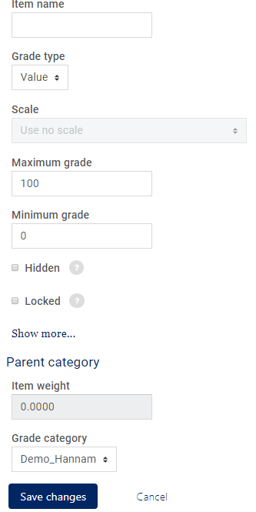

Entering grades
1. To enter grades return to the View tab.
- Option 1 - Under the assignment you would like to enter, click the dash for the student to enter the grade.
- Option 2 – Click the pencil next to the assignment. You also have the option to enter bulk grades, if you use this option.
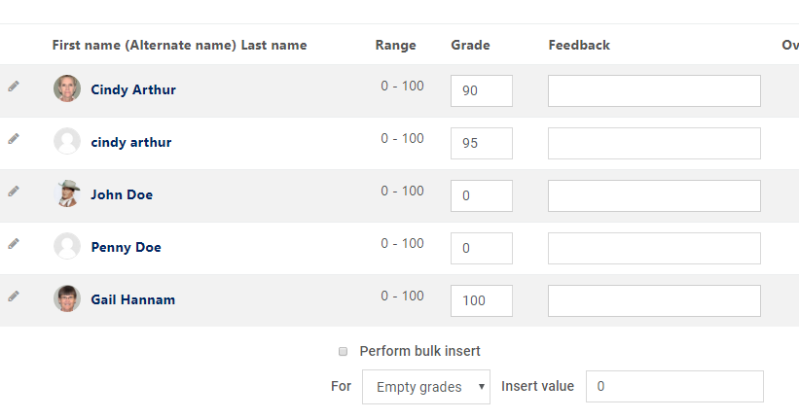

  - Enter your grades and Save

