Creating a Moodle Quiz with Settings

- Create a learning activity

- This will open the settings window for your quiz. Here you will give your quiz a name and add any descriptions, such as when it opens, due dates, etc. You must click the “Display description on course page” if you want the students to see this information. This is for the students benefit.

- It’s good practice to scroll to the bottom of the page and select “Expand All”
- The Timing section is one of the most important blocks of setting for a quiz. This is where you will set the open and close dates (limits when the student can take the quiz), time limits, what happens when time expires and if a grace period will be allowed. Note- You must click on “Show More” in the timing section in order to set the time limit.

Recommendations:
  - Opening the quiz is up to you. Do you want them to be able to access it at any time or only during a certain timeframe? You must check “Enable” to add dates and times.
Times use a 24-hour clock
  - Closing the quiz should be used if there is a definite due date/time for the quiz.
  - Time limit is instructor discretion. For online courses it is recommended to time the quiz so that every answer cannot be looked up or googled, unless this is okay with you. 30 seconds to no more than 1 minute per question is recommended (depending on question type).
  - When time expires should be left at “Open attempts are submitted automatically” unless you intend to offer a grace period. Do not set it at it at “Attempts must be submitted before time expires, or they are not counted! This setting will cause students to lose their answers if they do not submit by the time the timer runs out.
- The Grade section you will use only if you intend to allow the student more than one attempt on the quiz. (We recommend that you do not use grade categories.) If you allow the students more than one attempt then you will need to decide what grade will be recorded: Highest, Average, First Attempt or Last Attempt. Note- You must click on “Show More” in the grade section in order to set the number of attempts.

- Layout – Please choose under “New Page” every question. This is will save a student’s work after every question. This is beneficial if a student losses internet connectivity during the middle of a quiz.
- Navigation method can be “free” (meaning they can move around in the quiz, clicking on the questions in any order) or “sequential” (meaning that they have to answer the questions in order and cannot go back and revisit questions. Note- You must click on “Show More” in the Layout section in order to set the time limit.

- Review Options is one of the most important setting block for a quiz (and the most frequent area for mistakes). Recommended settings are in the screenshot below:

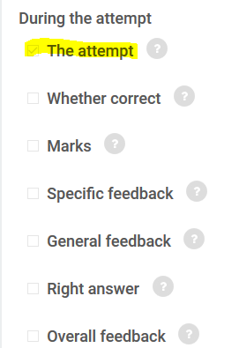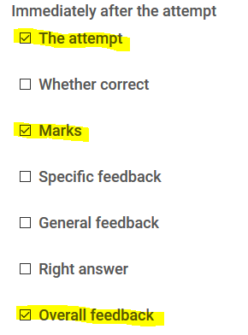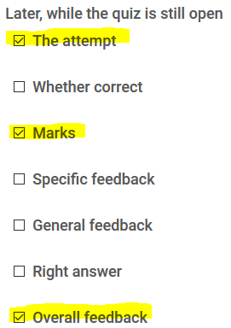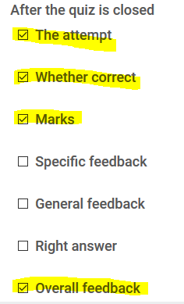

If you would like the student to see the right answer at any stage of the quiz, please check that option.

  - Shuffle within questions – If set to yes, it will randomize the question answers. In other words the correct answer for me might be A but for you might be B. This is another place that will discourage cheating but use with caution! If you have any questions where the correct answer is “All of the Above” or “A and C” this will mess that up!
  - How questions behave – this is where most of the confusion starts. There are only 3 that we recommend you choose at this point in time:
    - Deferred feedback – this is the most common. It simply means that during the quiz/exam, they get no feedback. This is the default and recommended for most cases.
    - Immediate feedback – this would allow them to see anything checkmarked in the “During the attempt” column. This would be good for study guides and selfcheck as you go.
    - Immediate feedback with multiple tries – would let them know how they did immediately and give them another chance.
  - Review Options:
During the attempt | = while taking the quiz
Immediately after the attempt | = the first 2 minutes after submitting
Later, while the quiz is still open | = after the first 2 minutes but before the quiz closes
After the quiz is closed | = after the set close date
The attempt | = being able to see the question and answer choices and how the question was answered
Whether correct | = green check mark shown if correct; red X if incorrect is shown
Marks | = score (must be checked for score to show in the gradebook)
Specific feedback | = individual question comments entered into the question bank, based on a correct or incorrect answer
General feedback | = general comments or information for each individual question, entered into the question bank
Right answer | = when question is answered incorrectly, the correct answer will be shown
Overall feedback | = comments regarding the quiz overall – does not pertain to individual questions

- Apperance – No changes will need to be made here unless you do not want 2 decimal places in grades. The other settings are self-explanatory but are seldom changed.

- Extra restrictions:
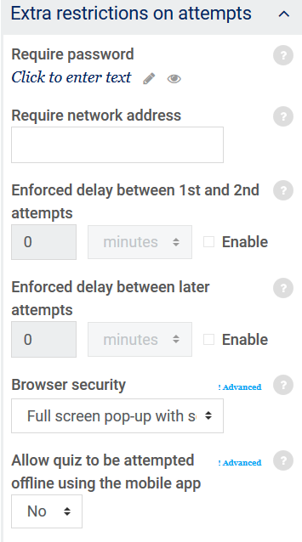

  - Require password – good for proctored exams
  - Require network address – not used at Carl Sandburg College
  - Enforced delays – only pertain if you have allowed multiple attempts. If so, you can force a delay before additional attempts to encourage extra study time.
  - Browser security –should stay at the default of “Full screen pop-up with some JavaScript security”. This will block the use of copy/paste and print.
- Overall feedback – allows you to display a comment(s) after quiz submission. Adding grade boundaries will allow different comments for different grade ranges. Ranges should always be highest to lowest with the comment in-between.
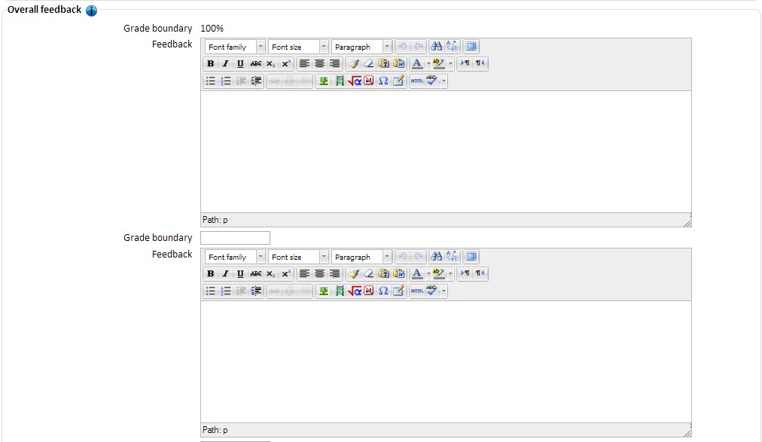
- Remaining settings should be left at their defaults unless groups are pre-setup in your course or you have turned on “activity completion” in your course settings. Never set date restrictions. These will override your open/close dates and will also restrict all access except during that time, including showing grades in the gradebook.
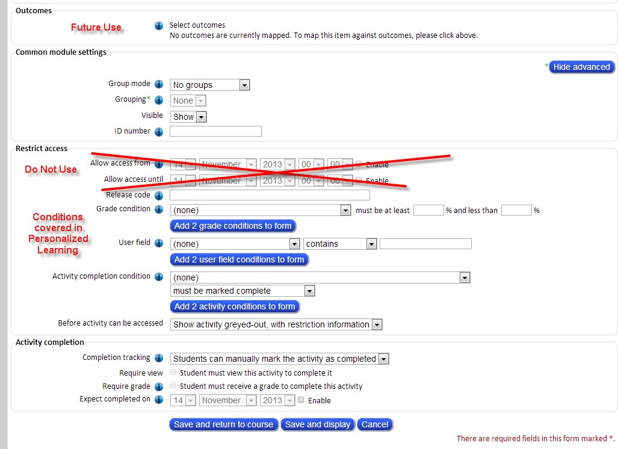
Activity completion (if turned on in settings) will give a checkbox for students to work through their course like a to-do list… checking things off as they go. You can control whether an item is checked with rules such as “Require view” or “Require grade”. Please contact the FTLC if you need help with these settings.
SAVE AND DISPLAY. Note that your quiz is not yet finished as it does not contain questions.

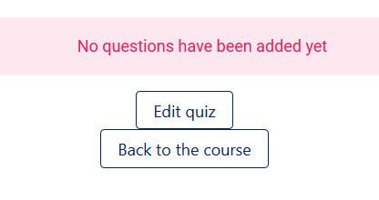
Click Edit Quiz

- Here you will add your questions either manually or from a test bank.

- You can Shuffle the order of the questions in the quiz

- Also set the Maximum grade

